Hazards of Assigned Seating

- Theatre-style row numbers occur in 3 locations: Hubbell/Hoyt/Goergen101
  - This means MIDDLE section is number starting with 100 and goes left to right as the instructor faces the students
  - LEFT section is numbered starting on the aisle stairway and goes to the LEFT (so from right to left as the instructor faces the students) AND all numbers are EVEN starting with "2".
  - RIGHT section is numbered starting on the aisle stairs and goes to the RIGHT (from right to left same as the MIDDLE) AND all numbers are ODD starting with "1" (see example below)
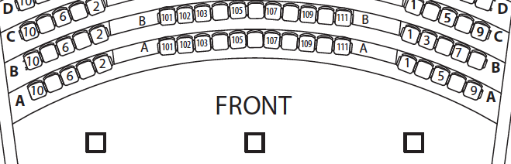
- Some rooms like Hubbell/Dewey1-101/Morey321 have existing seat plate numbers, but over time they can be vandalized or become inaccurate due to replacement.
  - In cases where a seat plate or label is missing, the seat chart for the room takes precedence over ALL discrepancies in the room. This accounts for situations where a seat is "removable" or has been replaced by facilities by another seat with an incorrect seat plate number.
  - Always use the PDF seat chart for the room as the absolute numbering system for that room. The spreadsheets for the room will match that PDF seat chart as closely as possible.
- In some old rooms, there is a truncated first row that was modified or added later. In cases where the front row is far to the right or left, the numbering may "skip" to match rows behind that row. Or in some cases the numbering may start at "1" and continue straight across in a continuous incremental progression.
- Dewey 1-101/Lattimore 201 BOTH have a Row Letter of capital "I", row letters go H,I,J,… But only for those 2 rooms. All other assigned seating rooms on campus will skip capital letter "I" for the sake of no mistaking it as a number "1".
- There are only 14 rooms that have been set aside by the Dean's Office space planning manager and they are as follows:
Hutchison 141 (Hubbell)  Lower Strong  Hoyt  Dewey 1-101  Hutchison 140 (Lander)  Goergen Hall 101 (Sloan)  Bausch & Lomb 109 | Lattimore 201  Morey 321  Meliora 203  Dewey 2-162  Bausch & Lomb 106  Meliora 221  Gavett 202

- There are 2 sets of directions/PDF charts/excel spreadsheets, so people need to be aware
  - One set for large enrollment classes during Common Exam time where:
    - Students are forced to sit in alternating seat arrangement with minimum of one seat separating each student in a row.
    - Students are divided into smaller groups and proctored at multiple locations.
  - The other set of directions are for people who just want to randomize seat assignments WITHIN their existing room location.

